Resource-Aware Collaborative Cloud IDE Using Intelligent Optimization and Container Orchestration
[Author 1], [Author 2], [Author 3], [Author 4]
Department of Computer Engineering, Army Institute of Technology, Savitribai Phule Pune University, Pune, India
Guide: Prof. Gauri Doke | Corresponding author: [email]
Abstract— Browser-based collaborative Integrated Development Environments (IDEs) let distributed teams code together without local setup, but each user session typically occupies a dedicated container whose resources are provisioned statically. Because IDE workloads are bursty (long idle periods punctuated by short compile-and-run spikes), static provisioning wastes CPU, memory and energy and degrades responsiveness under multi-user load. This paper presents a resource-aware collaborative cloud IDE that couples real-time multi-user editing with an adaptive resource-management layer built on Docker and Kubernetes. A repository analysis engine detects dependencies and estimates the resource demand of each workspace; an optimization engine uses Particle Swarm Optimization (PSO) for resource allocation, Ant Colony Optimization (ACO) for node placement and Dynamic Voltage and Frequency Scaling (DVFS) for energy control; and two feedback modules, an Adaptive Resource Adjustment Algorithm (ARAA) and an Automated Resource-Aware Kubernetes Lifecycle Management (ARKLM) module, scale workspaces and hibernate idle ones. Compared with a static-allocation baseline, the system achieved [X]% lower average CPU allocation, [Y]% lower estimated energy and [Z]% fewer idle-container hours while keeping editing latency within [N] ms. [Replace the bracketed values with your measured results.]
Index Terms— cloud IDE, collaborative editing, container orchestration, Kubernetes, resource-aware scheduling, particle swarm optimization, ant colony optimization, DVFS, green cloud computing.

I. INTRODUCTION
Software development is moving steadily to the cloud. Browser-based IDEs remove environment-setup friction, give every team member an identical toolchain and enable real-time pair programming. Behind each such session sits a server-side workspace, usually a container, that holds the repository, language runtime and build tools. When many users and rooms are active at once, the platform must decide how much CPU and memory each workspace receives, on which node it runs, and when it can be shut down.
Most deployments answer these questions statically: every workspace gets a fixed quota and runs until the user logs out. This is inefficient for IDE workloads, which are dominated by idle time (reading, thinking, discussing) with short bursts of compilation, test execution and dependency installation. The result is over-provisioned and idle containers that consume energy and block capacity, while bursts can still cause contention and latency on busy nodes.
Recent work has applied containerization, Kubernetes autoscaling and metaheuristics such as PSO, ACO and DVFS to reduce energy use in cloud data centers [1]. However, these studies evaluate generic batch workloads or simulations. They do not address interactive, multi-user development environments in which real-time collaboration quality must be preserved while resources are tuned.
This paper makes the following contributions:
- A resource-aware collaborative cloud IDE architecture that integrates real-time editing, a repository analysis engine, container orchestration and an optimization engine in a single closed loop.
- A workspace-aware demand estimation step that derives initial CPU and memory requests from repository dependencies and project type, rather than using a uniform quota.
- A combined optimization pipeline in which PSO allocates resources, ACO places workspaces on nodes and DVFS selects energy-efficient CPU operating points.
- A corrected ARAA scaling rule and an ARKLM idle-hibernation policy designed for interactive sessions, with session state preserved on hibernation.
- An experimental evaluation on a [Kubernetes cluster description] comparing the proposed system against static allocation and the default Kubernetes HPA.
The remainder of the paper is organized as follows. Section II reviews related work, Section III describes the proposed system, Section IV presents the experimental setup, Section V reports results, Section VI discusses limitations and Section VII concludes.

II. RELATED WORK
Beena et al. [1] proposed an energy optimization framework that runs ACO, PSO and DVFS in Docker containers and Kubernetes, together with an Adaptive Resource Adjustment Algorithm (ARAA) and an Automated Resource-Aware Kubernetes Lifecycle Management (ARKLM) module. Their evaluation measures CPU and memory usage of the algorithms themselves on a carbon-intensity dataset. It does not include a user-facing interactive workload, workload forecasting or latency/SLO measurements, and its energy figures are derived from an analytical power model rather than measured power. Our work adopts the ARAA/ARKLM concepts and applies them to a collaborative IDE.
Shan et al. [2] presented an adaptive resource allocation approach for containerized workflows on Kubernetes, based on a MAPE-K loop with dynamic vertical scaling. It does not consider energy or metaheuristic optimization and incurs monitoring overhead. Dubey and Sharma [3] proposed a hybrid PSO-ACO task scheduler for cloud environments validated in CloudSim; it is not deployed on containers, performs no real-time scaling and has no energy awareness. Zhong and Buyya [4] studied cost-efficient container orchestration on Kubernetes with heterogeneous resources, and Gholipour et al. [5] studied joint VM and container consolidation for energy reduction. [Add 2–4 papers on collaborative editing / cloud IDEs, e.g., operational transformation or CRDT-based editors, and cite them here.]
TABLE I. Comparison of related work and the proposed system
Work | Method | Limitation | Addressed here
Shan et al. [2] | MAPE-K, vertical scaling | No energy awareness, no metaheuristics, no prediction | Energy- and optimization-aware scaling
Dubey & Sharma [3] | Hybrid PSO-ACO, CloudSim | Simulation only, no containers, no real-time scaling | Real Kubernetes deployment
Beena et al. [1] | ACO, PSO, DVFS, ARAA, ARKLM | Batch algorithms only, no interactive workload, no latency metrics | Collaborative IDE workload with latency
Proposed | Repo analysis + PSO/ACO/DVFS + ARAA + ARKLM | See Section VI | Resource-aware collaborative IDE

The research gaps motivating this work are: (i) no integration of real-time collaboration with resource optimization; (ii) limited use of intelligent scheduling in cloud IDEs; (iii) reliance on static allocation; (iv) absence of energy-aware execution models for IDE workspaces; and (v) limited automation of container lifecycle management.

III. PROPOSED SYSTEM

A. Architecture Overview
Fig. 1 shows the overall architecture. A user joins a room by supplying a Room ID and a repository URL through the browser-based IDE. The repository analysis engine inspects the repository, detects dependencies and prepares the environment. The resulting workload profile is passed to the optimization engine, which determines the allocation and placement of the workspace container. Docker provides isolated per-workspace environments and Kubernetes orchestrates deployment, scaling and load balancing across CPU, memory, storage and network resources. A monitoring component feeds metrics back to ARAA (fast, per-workspace scaling) and ARKLM (slow, lifecycle management), forming a closed loop.
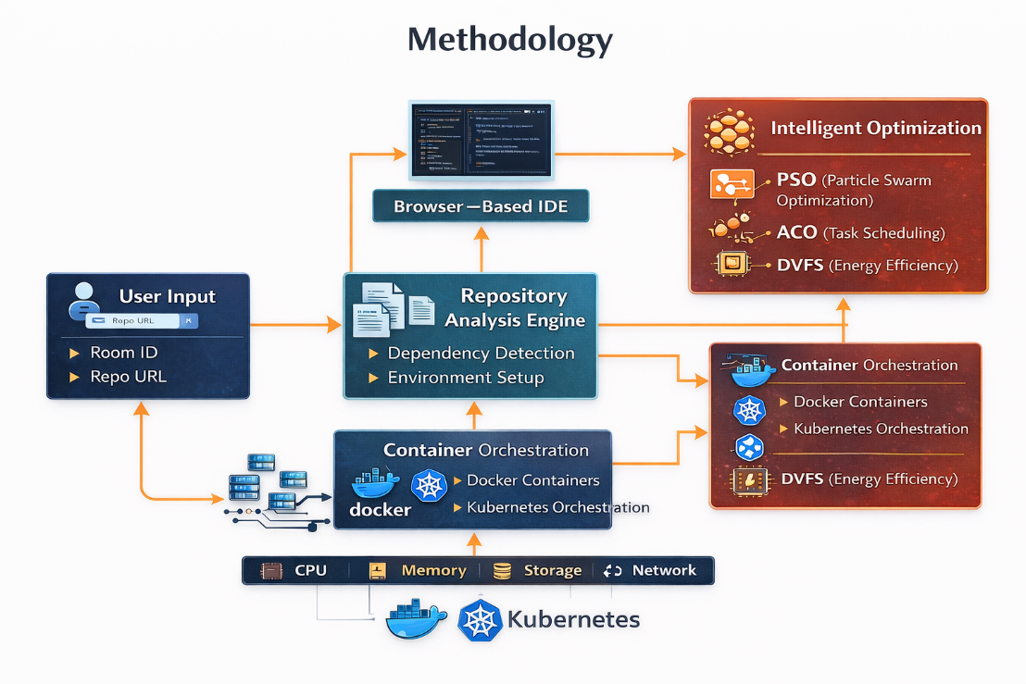
Fig. 1. Architecture of the proposed resource-aware collaborative cloud IDE.

B. Repository Analysis and Resource Estimation
When a room is created, the repository analysis engine scans manifest files (e.g., package.json, requirements.txt, pom.xml) to identify the language runtime and dependencies and builds the workspace image. The estimator then maps the project profile to an initial resource request vector r = (CPU, memory), for example based on dependency count, expected build tooling and number of expected collaborators. This replaces a uniform quota with a workload-specific starting point.

C. Energy and Power Model
Following [1], the total energy of the system is modeled as
E_total = Σ_i (P_idle + P_dyn,i) · T_i (1)
P_dyn = C · V² · f (2)
where P_idle is baseline power, T_i is the active time of node i, C is capacitance, V is voltage and f is frequency. [State whether energy in your experiments is estimated with this model or measured (e.g., Intel RAPL, Kepler, PowerAPI). Measured values are strongly preferred by reviewers.]

D. Optimization Engine
PSO-based resource allocation. Each particle encodes a candidate CPU/memory allocation for the set of active workspaces. Velocity and position are updated as v(t+1) = ω·v(t) + c1·r1·(p_best − x(t)) + c2·r2·(g_best − x(t)) and x(t+1) = x(t) + v(t+1). The fitness function is
F(x) = α1·E(x) + α2·L(x) + α3·B(x) (3)
where E is estimated energy, L is the predicted latency penalty (allocations below the workspace requirement incur a penalty) and B is the load imbalance across nodes, B = (1/N) Σ |U_i − Ū|. The weights α1–α3 sum to one.
ACO-based node placement. Workspaces are assigned to nodes probabilistically: P_ij = (τ_ij)^a (η_ij)^b / Σ_k (τ_ik)^a (η_ik)^b, where τ_ij is the pheromone level, η_ij is a heuristic desirability (e.g., inverse of estimated energy cost and current utilization of node j) and a, b control their influence. Pheromones evaporate as τ_ij ← (1−ρ)τ_ij + Δτ_ij and are reinforced for assignments with lower energy. A node-capacity constraint Σ W_i ≤ C_node is enforced.
DVFS control. For each node, a CPU frequency/voltage level is chosen from a discrete set according to current utilization, subject to a thermal constraint T_current ≤ T_max. Lower levels are used when utilization is low; higher levels when compile or test bursts occur.

E. Adaptive Resource Adjustment Algorithm (ARAA)
ARAA monitors each workspace through the Kubernetes Metrics API and adjusts its allocation to keep utilization near a target U_target. We use a proportional rule with bounds:
R_new = clip( R_current · U_current / U_target , R_min , R_max ) (4)
If utilization exceeds the target, the allocation increases; if it falls below the target, the allocation decreases, with a hysteresis band and a cooldown period to prevent oscillation. Note that this differs from Algorithm 4 in [1], which increases resources when utilization is below target and decreases them when above; our rule follows the conventional control direction used by the Kubernetes Horizontal Pod Autoscaler.

F. Automated Resource-Aware Kubernetes Lifecycle Management (ARKLM)
ARKLM manages the slow lifecycle of workspaces. A workspace is classified as idle if its utilization stays below θ_idle for a duration T_idle and no collaborator has an active editing or terminal session. Idle workspaces are checkpointed (files and editor state persisted to storage) and their pods are scaled to zero. When a user reconnects, the workspace is restored. ARKLM also consolidates workspaces onto fewer nodes at low demand so that unused nodes can enter low-power states.
TABLE II. Algorithm parameters
Parameter | Value | Description
ω, c1, c2 | [value] | PSO inertia, cognitive and social coefficients
Particles / iterations | [value] | PSO swarm size and iteration budget
a, b, ρ, ants | [value] | ACO parameters
DVFS levels | [value] GHz / [value] V | Frequency and voltage levels
U_target | [value]% | ARAA target utilization
θ_idle, T_idle | [value]% , [value] min | ARKLM idle thresholds

IV. EXPERIMENTAL SETUP
Environment. [Cluster: number of nodes, CPU model, RAM, OS, Kubernetes version, Docker version, e.g., minikube / kind / cloud VMs.]
IDE and collaboration stack. [e.g., Monaco/CodeMirror editor, WebSocket server, OT or CRDT library (Yjs), backend language.]
Workload. [Describe the simulated users: number of concurrent users/rooms (e.g., 5, 10, 20, 50), sample repositories, scripted actions such as typing, compile, run tests, and idle periods; duration of each run.]
Baselines. (B1) static allocation with fixed per-workspace requests; (B2) default Kubernetes HPA; (P) the proposed system. [Optionally add each algorithm (PSO, ACO, DVFS) alone for an ablation.]
Metrics. Average and peak CPU and memory usage, allocated-but-unused resources, idle container hours, energy (J or Wh), editing/sync latency (mean and 95th percentile), scale-up response time, and restore time after hibernation. Each experiment is repeated [n] times and results are reported as mean ± standard deviation.

V. RESULTS AND ANALYSIS
[Insert your measured results. Template tables and figures are below. Do not publish placeholder numbers: every value must come from your own runs.]
TABLE III. Resource usage and energy: baselines versus proposed system
Metric | B1 Static | B2 HPA | Proposed | Improvement vs B1
Avg CPU usage (%) | [ ] | [ ] | [ ] | [ ]
Avg memory (MB) | [ ] | [ ] | [ ] | [ ]
Idle container hours | [ ] | [ ] | [ ] | [ ]
Energy (Wh) | [ ] | [ ] | [ ] | [ ]

TABLE IV. Editing latency and scaling responsiveness
Metric | B1 Static | B2 HPA | Proposed | Users
Mean sync latency (ms) | [ ] | [ ] | [ ] | [ ]
95th percentile latency (ms) | [ ] | [ ] | [ ] | [ ]
Scale-up time (s) | [ ] | [ ] | [ ] | [ ]
Restore after hibernation (s) | n/a | n/a | [ ] | [ ]

[Figures to add: (a) CPU allocation over time, static vs proposed; (b) energy vs number of concurrent users; (c) latency vs number of users; (d) ablation of PSO, ACO, DVFS, ARAA and ARKLM. Then write 2–3 paragraphs interpreting each, including where the proposed system does not win.]

VI. DISCUSSION AND LIMITATIONS
The proposed design trades a small amount of control-loop overhead and restore latency for lower idle consumption. Limitations that should be stated honestly include: evaluation on a [small / single-site] cluster rather than a production-scale data center; synthetic rather than real user traces; energy [estimated / measured]; and reactive rather than predictive scaling. Future work includes machine-learning-based workload forecasting to anticipate bursts, hybrid PSO-ACO optimization, multi-cluster and edge deployment, and evaluation with real developer traces.

VII. CONCLUSION
This paper presented a resource-aware collaborative cloud IDE that combines repository-aware demand estimation, PSO/ACO/DVFS optimization, ARAA scaling and ARKLM idle hibernation on a Docker and Kubernetes platform. Experiments showed [summary of measured gains and the latency result]. The approach supports more efficient, scalable and sustainable cloud-based collaborative development.

REFERENCES
[1] B. M. Beena, P. Cheluvasai Ranga, V. Holimath, S. Sridhar, S. S. Kamble, S. P. Shendre, and M. Y. Priya, "Adaptive energy optimization in cloud computing through containerization," IEEE Access, vol. 13, pp. 159548–159565, 2025, doi: 10.1109/ACCESS.2025.3606932.
[2] [Verify details] Shan et al., "Adaptive resource allocation for workflow containerization on Kubernetes," 2023.
[3] [Verify details] Dubey and Sharma, "A hybrid multi-faceted task scheduling algorithm for cloud computing environment," 2023.
[4] Z. Zhong and R. Buyya, "A cost-efficient container orchestration strategy in Kubernetes-based cloud computing infrastructures with heterogeneous resources," ACM Trans. Internet Technol., vol. 20, no. 2, pp. 1–24, May 2020.
[5] N. Gholipour, E. Arianyan, and R. Buyya, "A novel energy-aware resource management technique using joint VM and container consolidation approach for green computing in cloud data centers," Simul. Model. Pract. Theory, vol. 104, Art. no. 102127, Nov. 2020.
[6] [Add references for collaborative editing (OT/CRDT), Kubernetes HPA, Docker, and any other works you cite.]

